NRD Water Programs Conference
February 28, 2017
Holiday Inn, Kearney, NE

MORNING SESSION

8:00 - Program Preview
Dan Clement, CPNRD

8:05 - State/Federal Agency Updates
Dan Snow, UNL – Amy Zoller, NDNR – Kevin Breece, NRCS

8:45 - NRD Panel: Water Meters & Telemetry
John Bush, UBBNRD - Marie Krausnick, UBBNRD - Curt Becker, LENRD - Duane Woodward, CPNRD -
Seth Popp, NPNRD - Scott Schaneman, NPNRD

9:45 - Break

10:00 - Groundwater Quality Issues (fertilizer spills, UIC, and nitrates) – Bazile Groundwater Management Plan (what it means to NRDs) – WHP and Drinking Water Management Plans (what it means to NRDs)
Dave Miesbach, Laura Johnson & Sam Radford - NDEQ

10:45 - Papio NRD Groundwater Management Plan
Paul Woodward, Papio NRD

11:30 - Lunch/ Platte River Basin Time-Lapse Project

AFTERNOON SESSION

12:30 - NRD Panel: Permits & Variances
Larry Angle, LPNNRD – Chuck Wingert, NNRD – Kevin Orvis, LBNRD – Tylr Naprstek, LLNRD

1:30 - Microcystin – Beach Closures, Past & Future
Mike Archer, NDEQ

2:15 - Break

2:30 - Groundwater Recharge: Current Research & Future Directions
Chris Hobza, USGS
SPEAKER INFORMATION

Dan Clement is the Water Resources Specialist for the Central Platte NRD.
Kevin Breece is a NRCS District Conservationist located in Elm Creek.
Dr. Daniel Snow is the Laboratory Services Director for the University of Nebraska Lincoln
Amy Zoller is a Coordinator for the Integrated Water Management Planning division of the Nebraska Department of Natural Resources.
John Bush is a Water Resources Technician with the Upper Big Blue NRD.
Marie Krausnick is the Water Department Manager for the Upper Big Blue NRD.
Curt Becker is a Water Resources Specialist with the Lower Elkhorn NRD.
Duane Woodward is an Engineering Hydrologist for the Central Platte NRD.
Seth Popp is a Water Resources Technician for the North Platte NRD.
Scott Schaneman is the Water Resources Coordinator for the North Platte NRD.
Dave Miesbach is the Groundwater Unit Supervisor in the Water Quality Division of the Nebraska Department of Environmental Quality.
Laura Johnson is the Integrated Report and TMDL Coordinator for the Nebraska Department of Environmental Quality.
Sam Radford is the Wellhead Protection Program Coordinator at the Nebraska Department of Environmental Quality.
Paul Woodward is the Groundwater Management Engineer at the Papio-Missouri River NRD.

SPEAKER INFORMATION
Larry Angle is the Water Resources Manager for the Lower Platte North NRD.
Tylr Naprstek is the Modeling Coordinator for the Lower Loup NRD.
Kevin Orvis is the Projects Manager for the Little Blue NRD.
Chuck Wingert is the Water Resources Manager for the Nemaha NRD.
Mike Archer is a Program Specialist in the Surface Water Unit in the Water Quality Division of the Nebraska Department of Environmental Quality.
Chris Hobza is a Hydrologist at U.S. Geological Survey (USGS) focusing on groundwater/surface-water interaction, groundwater recharge, and geologic framework studies.

CEU INFORMATION

The NARD will apply for 5.5 Continuing Education Units (CEUs) for all categories of NDHHS water well licenses and certificates for this conference.

To qualify you must attend the entire day and sign in at the end of the day. Please make sure to scan your card, or if you do not have your card please sign in on the Sign-In sheet!

CEU opportunities are also available at the NARD Annual Conference in September. To check other CEU opportunities throughout the year visit: http://dhhs.ne.gov/publichealth/Pages/enh_wwsindex.aspx

Please take time to thank the following individuals for serving on the organizational committee for the Water Programs Conference:

Rod DeBuhr, Upper Big Blue NRD
Marie Krausnick, Upper Big Blue NRD
Dan Clement, Central Platte NRD
Larry Angle, Lower Platte North NRD
Russell Oaklund, Lower Platte North NRD
Daryl Andersen, Little Blue NRD
Dick Ehrman, Lower Platte South NRD
Nolan Little, Tri-Basin NRD
Dustin Wilcox, NARD
Jennifer Swanson, NARD

A special Thank You to our MC Dan Clement!

Thanks Again to Our Monday Night Hospitality Room Sponsor:

Please take the time to complete your evaluation. Completed evaluations provide the committee with ideas and suggestions for improving future conferences!

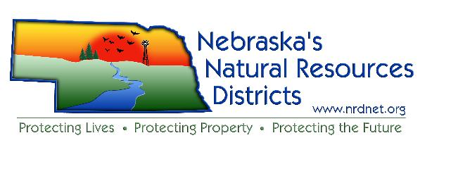

Nebraska Association of
Resources Districts
601 S. 12th Street, Suite 201
Lincoln, NE 68508
(402)471-7670
nard@nrdnet.org
www.nrdnet.org

2017 NRD Water Programs Conference
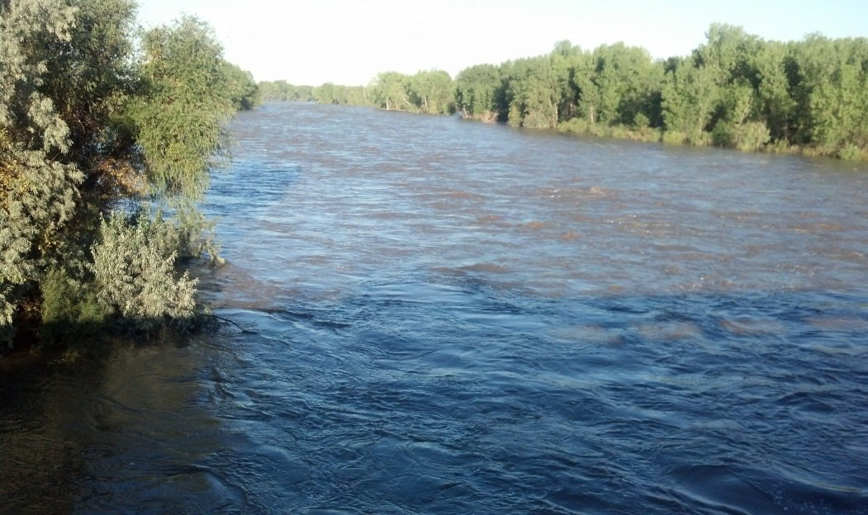
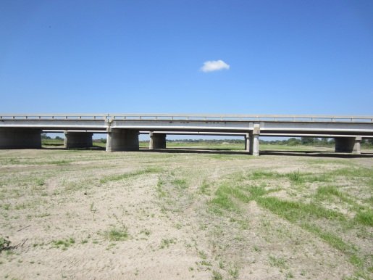
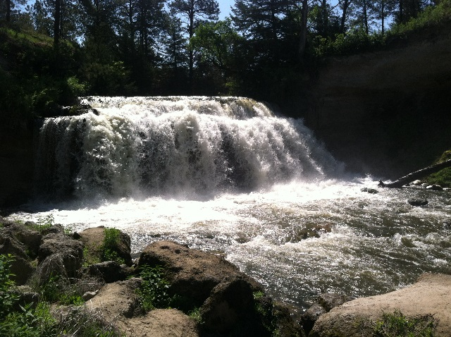

February 28, 2017
Holiday Inn &
Conference Center
Kearney, NE

